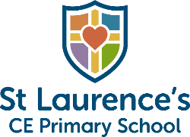

St. Laurence's Church of England Academy
No Outsiders book list
Growing in Faith, Living in Hope, Learning to Love

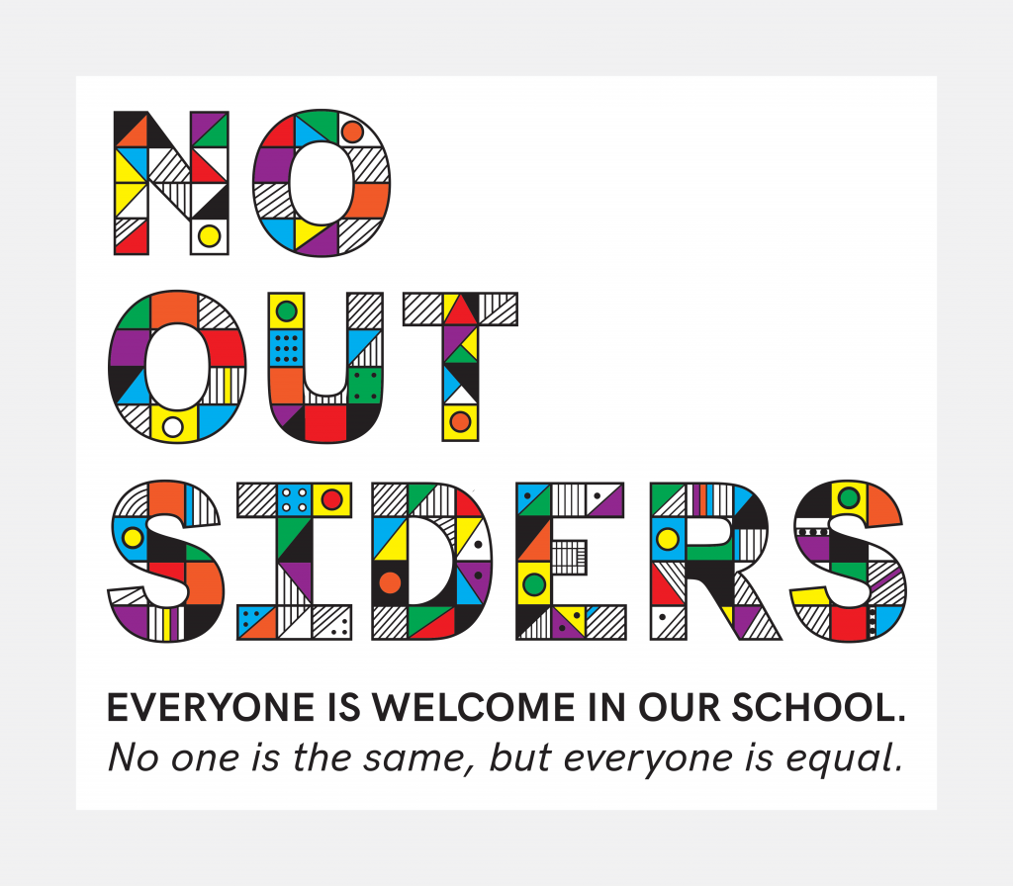

EYFS
Text | Description
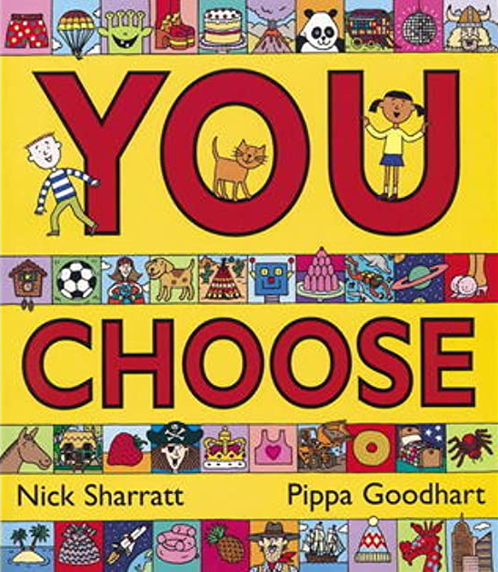  You Choose (by Nick Sharratt and Pippa Goodheart) | Imagine you could go anywhere, meet anyone and do anything. Where would you live? Where would you sleep? Who would be your friends? What games would you play? Go on . . . you choose!  With the help of Nick Sharratt's wonderfully detailed illustrations, Pippa Goodheart explores a whole range of scenarios where choosing is made fun! This is a timeless classic which children will love to return to again and again - and there's something new to find on every read!
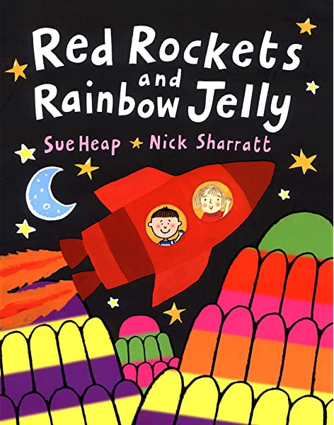  Red Rockets and Rainbow Jelly (by Sue Heap and Nick Sharratt) | This very simple text is about two friends, Sue and Nick, who like different colours but are still good friends. The artwork is stunning with each artist contributing alternate pages in their own inimitable style.
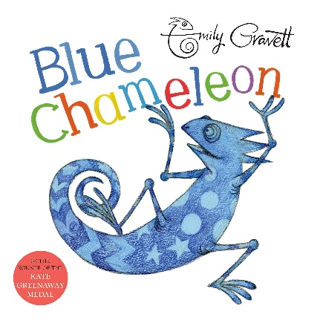  Blue Chameleon (by Emily Gravett) | This chameleon can turn into anything and appear to fit in anywhere, but it seems that neither the swirly snail, the green grasshopper nor the stripy sock want to be friends. Will the chameleon ever find someone to talk to?  With a subtle and witty interplay between words and illustrations Emily Gravett's Blue Chameleon is an introduction to colours and shapes (and chameleons!) which is sure to delight readers of all ages.
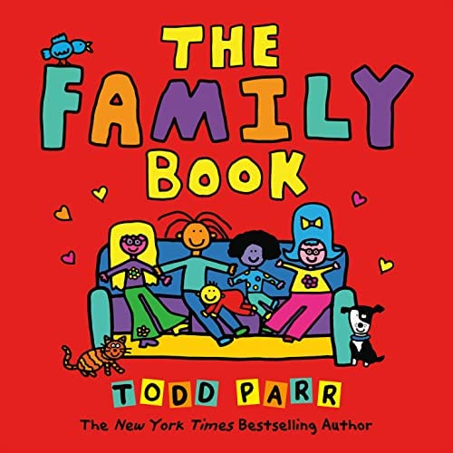  The Family Book (by Todd Parr) | The Family Book celebrates families and all the different varieties they come in. Whether they're big or small, look alike or different, have a single parent or two, Todd Parr assures readers that every family is special in its own unique way.
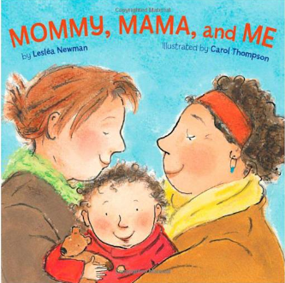  Mommy Mama and Me (by Leslea Newman and Carol Thompson) | Rhythmic text and illustrations with universal appeal show a toddler spending the day with its mommies. From hide-and-seek to dress-up, then bath time and a kiss goodnight, there's no limit to what a loving family can do together. Shares the loving bond between same-sex parents and their children.

Year 1
Text | Description
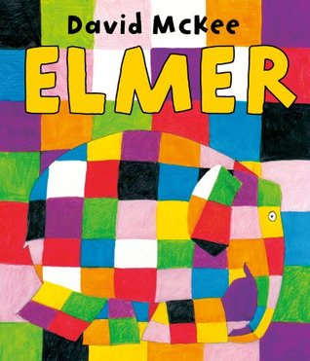  Elmer (by David McKee) | When Elmer discovers a bush in the jungle with elephant-coloured berries, he shakes the bush and rolls in a berry mash until he is as grey as the others. Now no one seems to notice him; for a time he enjoys his anonymity, but after a while he begins to realize just how quiet and dull things are when he's not around.
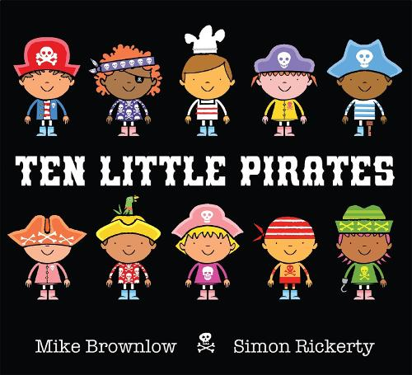  Ten Little Pirates (by Mike Brownlow and Simon Rickerty) | The Ten Little Pirates are sailing out to sea ... But what will the Ten Little Pirates do when they meet a singing mermaid? And a whooshing hurricane? And a HUNGRY shark?  Part traditional counting rhyme, part fun-filled story, Ten Little Pirates is perfect for sharing together. Count from ten to one and back again, as the Little Pirates disappear then reappear.
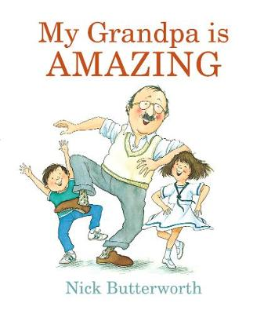  My Grandpa is Amazing (by Nick Butterworth) | An exuberant celebration of a wonderful grandpa - and all grandpas everywhere!  The grandpa in this book is truly brilliant. He builds fantastic sandcastles, he makes wonderful flower arrangements, and he's very, very, very patient. He's got an amazing bike, he's a terrific dancer and he knows all about first aid ... in fact there's very little this astounding grandpa can't do.
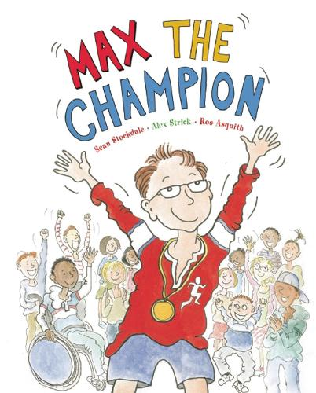  Max the Champion (by Sean Stockdale, Alexandra Strick and Ros Asquith) | Max is mad about sport. As he gets up, has breakfast and heads off to school, he is dreaming of competing in world class sporting events. In his real day, he and his class win the school football match and, in his imagination, he and his friends are winning the World Cup. This is a lively and fun approach to sport, and a very inclusive picture book showing disabled children and children without disabilities enjoying different sports together in a natural way. The sports include football, rugby, athletics, cricket, diving, discus throwing and cycling.
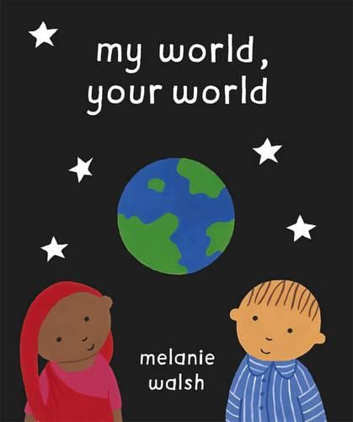  My World, Your World (by Melanie Walsh) | Pierre says 'bonjour'. George says 'hello'. But ...they both say 'achoo!' when they sneeze. The world is full of all sorts of people, speaking different languages and living different kinds of lives, but deep down people are basically the same wherever they live.

Year 2
Text | Description
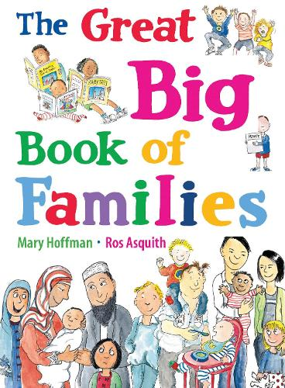  The Great Big Book of Families (by Mary Hoffman and Ros Asquith) | What is a family? Once, it was said to be a father, mother, boy, girl, cat and dog living in a house with a garden. But as times have changed, families have changed too, and now there are almost as many kinds of families as colours of the rainbow - from a mum and dad or single parent to two mums or two dads, from a mixed-race family to children with different mums and dads, to families with a disabled member.  This is a fresh, optimistic look through children's eyes at today's wide variety of family life: from homes, food, ways of celebrating, schools and holidays to getting around, jobs and housework, from extended families, languages and hobbies to pets and family trees.
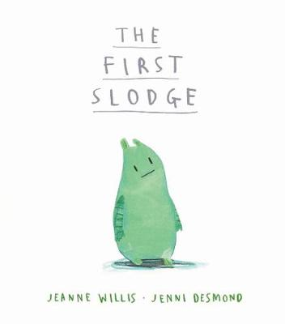  The First Slodge (by Jeanne Willis) | Once upon a slime, there was a Slodge. The first Slodge in the universe. She saw the first moon and stars, the first fruits and flowers. "Mine, all mine!" she said. But what if there was not just one Slodge . . . but two?  A wonderfully original and witty picture book. This humorous exploration of sharing and friendship carries an important message: that the world belongs to everyone.
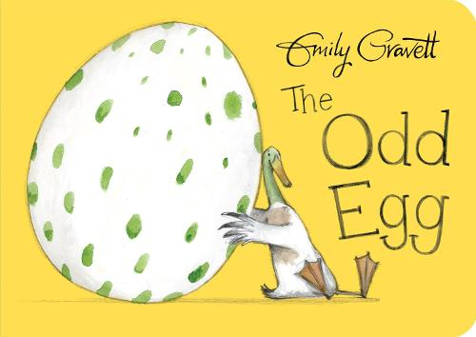  The Odd Egg (by Emily Gravett) | All the birds have eggs to hatch. All except Duck. But when Duck finds an egg of his own to look after he's delighted - it's the most beautiful egg in the whole world! But all the other birds think it's a very odd egg indeed - and everyone's in for a BIG surprise when it finally hatches.
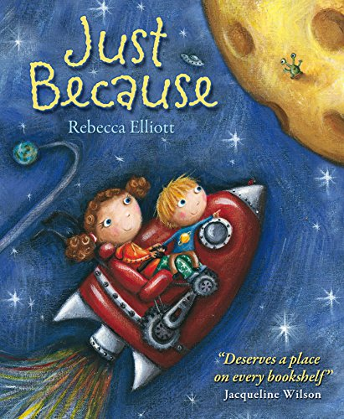  Just Because (by Rebecca Elliot) | A younger brother describes all the fun he has with the big sister he loves so much—just because, in this heartwarming picture book about being perfectly loved, no matter what. He is enthusiastic about just how loving and special she is, and delights in telling us about all the fun things they do together. Only as his tale unfolds does the reader begin to realize that his sister has special needs—and by then the reader just accepts, as he does, all the wonderful things about her.
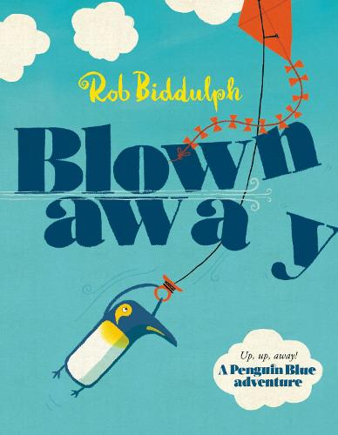  Blown Away (by Rob Biddulph) | Come on an unexpected journey with a fearless blue penguin in the most captivating picture book debut of the year!  Meet Penguin Blue, in this Waterstones Children's Book Prize winning tale!  It's a windy day, and he has a brand new kite - but where's he going on this maiden flight?  Penguin Blue and his friends go on a gloriously illustrated adventure full of good ideas, homesickness and the perils of kites.

Year 3
Text | Description
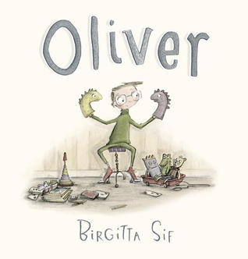  Oliver (by Birgitta Sif) | An imaginative child who doesn’t quite fit in finds a kindred spirit in this utterly charming picture book from a debut author-illustrator.  Oliver is different. He enjoys his solitude. He likes playing with his friends, who are puppets, stuffed animals, and other toys. With his rich imagination, Oliver’s day is never dull. There are bridges to cross, sharks to fight, and treasures to find! But maybe toys don’t always give a boy everything he needs. Maybe he needs another kind of companion. Will Oliver discover a way to be, well, different? When his tennis ball rolls across the lawn into the yard of the girl next door, he just might be surprised.
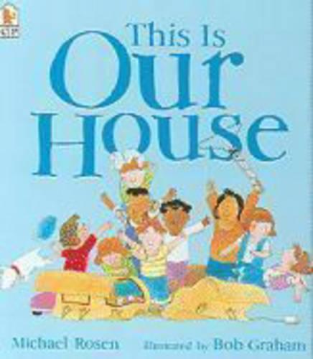  This is Our House (by Michael Rosen) | George says the cardboard house is his and no one else can play in it. It isn't for girls, small people, twins, people with glasses, or people who like tunnels. But Lindy, Marly, Freddie, Charlene, Marlene, Luther, Sophie and Rasheda have other ideas! One by one each child is refused access until tables are turned and George finds how it feels to be on the receiving end. A topical and perceptive book that shows that it is much more fun to share.
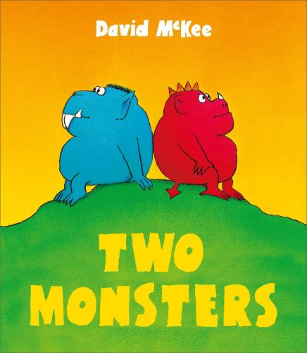  Two Monsters (by David McKee) | Two monsters live on either side of a mountain. Sometimes they talk through the hole in the mountain, but they never see each other. One evening, they get into a silly argument about whether day is departing or night is arriving, which escalates into a rock throwing fight, which eventually destroys the mountain, and enables the monsters to see each other's point of view and live together as friends.
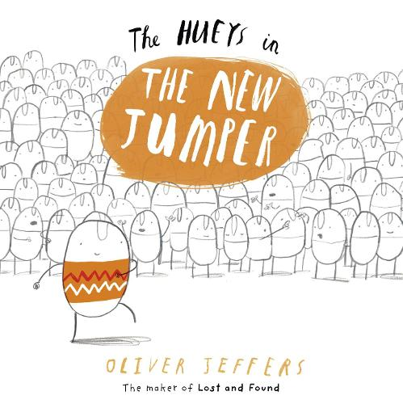  The Hueys in the New Jumper (by Oliver Jeffers) | The thing about the Hueys is that they are all the same. They all look the same, think the same and do the same things. Until one day, Rupert knits himself a new jumper...  How will the other Hueys react?  A hilarious story about individuality.
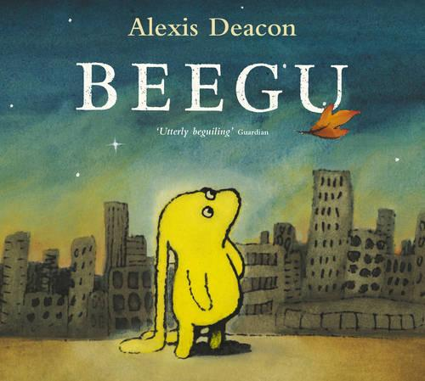  Beegu (by Alexis Deacon) | Beegu is not supposed to be on Earth. She is lost. She is a friendly little creature, but the Earth People don't seem very welcoming at all. However, so far she has only met the BIG ones. The little ones are a different matter.

Year 4
Text | Description
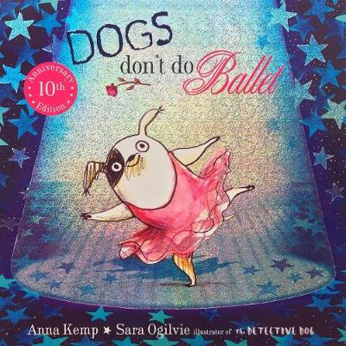  Dogs Don’t Do Ballet (by Anna Kemp and Sarah Ogilvie) | Meet Biff, an adorable little puppy who will stop at nothing to become a ballet dancer.  My dog is not like other dogs. He doesn't do dog stuff like weeing on lampposts or scratching his fleas, or drinking out of the toilet. No, my dog likes moonlight and music and walking on his tiptoes. You see, my dog doesn't think he's a dog. My dog thinks he's a ballerina!  A fabulous feel-good book about a small dog with a big personality and even bigger dreams.
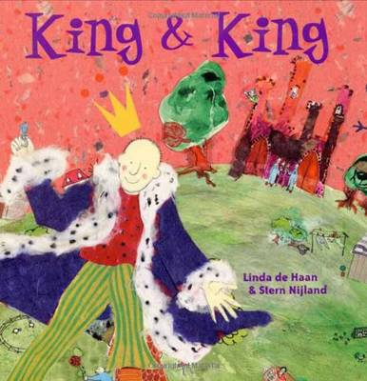  King and King (by Linda de Hann and Stern Nijland) | The Crown Kitty and Friends Cordially Invite You to Celebrate a Royal Wedding  Reception to follow in the Royal Gardens…  On a mountain high above town, young Prince Bertie lives with his mother. Tired of being Queen, she is desperate to find Bertie a princess to marry so he can inherit the throne, so she scours the world, looking for a suitable bride but all Bertie says is “I’ve never cared much for princesses”.  It seems like the Queen is never going to find a suitable match for Bertie and then Princess Madeleine pays the court a visit, accompanied by her brother, Prince Lee. Has Bertie finally met his match?
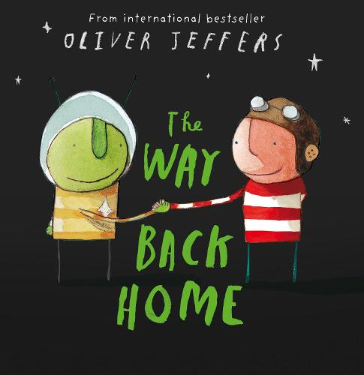  The Way Back Home (by Oliver Jeffers) | Once there as a boy, and one day, he found an aeroplane in his cupboard...  He didn't remember leaving it in there, but he thought he'd take it out for a go right away. At first, all went well and the plane flew higher and higher and higher until... suddenly, with a splutter, it ran out of petrol. The boy was stuck on the moon... and he was not alone...
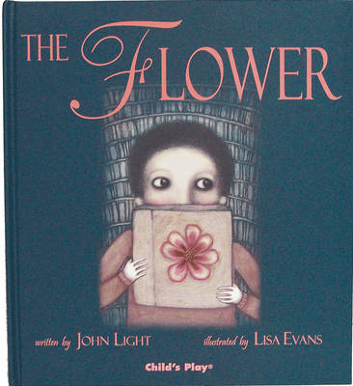  The Flower (by John Light) | Brigg lives in a small, grey room in a large, grey city. When he finds a book in the library labelled 'Do Not Read', he cannot resist taking it home. In it, he comes upon pictures of bright, vibrant objects called flowers. He cannot find flowers anywhere in the city, but stumbles instead on a packet of seeds. This sets off a chain of events which bring about unexpected results, continuing to grow and bloom even after we have turned the last page.
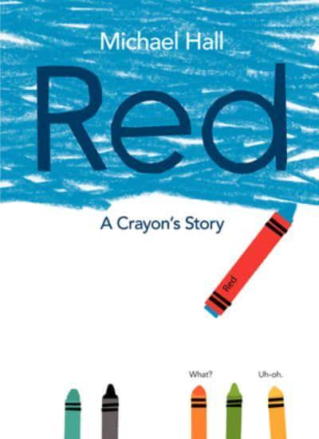  Red: A Crayon’s Story (by Michael Hall) | Red has a bright red label, but he is, in fact, blue. His teacher tries to help him be red (let's draw strawberries!), his mother tries to help him be red by sending him out on a playdate with a yellow classmate (go draw a nice orange!), and the scissors try to help him be red by snipping his label so that he has room to breathe. But Red is miserable. He just can't be red, no matter how hard he tries! Finally, a brand-new friend offers a brand-new perspective.

Year 5
Text | Description
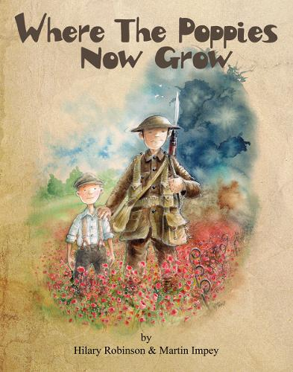  Where the Poppies Now Grow (by Hilary Robinson and Martin Impey) | Childhood friends, Ben and Ray, find their innocent war games become real as the Great War rages around them. Set during the First World War, in simple rhyme, Where the Poppies Now Grow takes readers on a journey of friendship set against a changing landscape of innocence, of war and then finally, of peace.
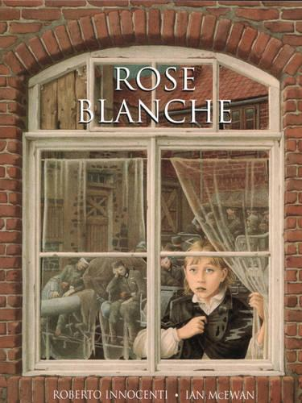  Rose Blanche (by Ian McEwan and Roberto Innocenti) | Rose Blanche was the name of a group of young German citizens who, protested against the war. Like them, Rose observes all the changes going on around her which others choose to ignore. She watches as the streets of her small town fill with soldiers. One day she sees a boy escaping from the back of a truck, only to be captured and shoved back into it. Rose follows the truck to a desolate place, where she discovers many other children, staring hungrily from behind an electric barbed wire fence. She starts bringing the children food, instinctively sensing the need for secrecy. Until the tide of the war turns and soldiers in different uniforms stream in from the East, and Rose and the imprisoned children disappear for ever . . .
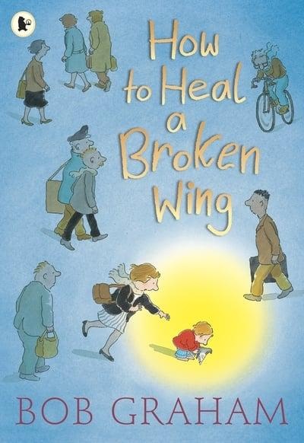  How to Heal a Broken Wing (by Bob Graham) | In a spare urban fable, Bob Graham brings us one small boy, one loving family, and one miraculous story of hope and healing.  In the busy city, no one sees the bird lying on the pavement with a broken wing. No one, except a young boy named Will. With the help of his parents, Will takes the bird home to care for it. With rest, time, and a little hope, perhaps the bird will fly again.  A paperback edition of a magical story, endorsed by Amnesty International UK.
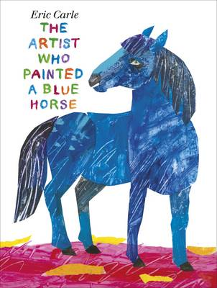  The Artist Who Painted a Blue Horse (by Eric Carle) | "I am an artist..." begins Eric Carle's vibrant tribute to the creative life. And just like an imaginative child, this is one artist who paints the world as he sees it - a red crocodile, an orange elephant, a purple fox, a black polar bear and a wonderful polka-dotted donkey. Filled with some of the most magnificently colourful animals of Eric Carle's career, this is a book that celebrates imagination and the artist within us all. Inspired by the work of the great Expressionist painter Franz Marc, a founder of the artists' group known as "Der Blaue Reiter" ("The Blue Rider"), who famously used abstract blue horses in his paintings. Marc's vibrantly colourful paintings influenced generations of artists, and fired the imaginations of children's book artists far and wide. Examples of Marc's paintings and a short biography are included at the end of the book.
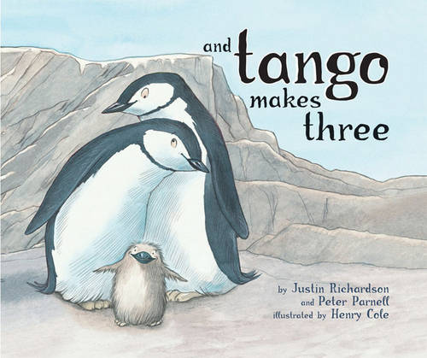  And Tango Makes Three (by Justin Richardson and Peter Parnell) | Roy and Silo are just like the other penguin couples at the zoo - they bow to each other, walk together and swim together. But Roy and Silo are a little bit different - they're both boys.  Then, one day, when Mr Gramzay the zookeeper finds them trying to hatch a stone, he realises that it may be time for Roy and Silo to become parents for real.

Year 6
Text | Description
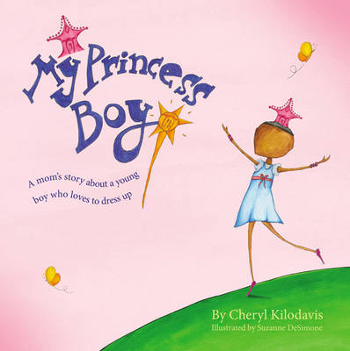  My Princess Boy (by Cheryl Kilodavis and Suzanne DeSimone) | My Princess Boy is a 2009 children's picture book written by Cheryl Kilodavis and illustrated by Suzanne DeSimone. The story centres on a boy who likes "pretty things" and prefers to wear tiaras and "girly dresses." The story informs readers about supporting children regardless of their expression.
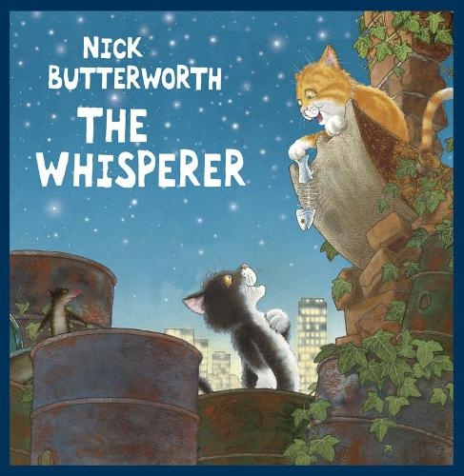  The Whisperer (by Nick Butterworth) | An edgy new picture book from the renowned creator of Percy the Park Keeper. Two gangs of cats live in a scrap yard on the edge of the city. When they're not eating or sleeping, they're fighting, and that's just how The Whisperer likes it. He's a rat, and if he can keep the cats going after each other, they'll leave him and his kind alone. But just maybe, things in the scrap yard are about to change for the better. Or as The Whisperer sees it...for the worse...
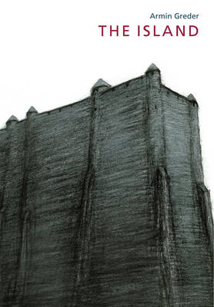  The Island (by Armin Greder) | In the morning the people of the island found a man sitting on the shore, there where fate and the ocean currents had set him and his frail raft in the night. When he saw them coming towards him, he rose to his feet. He was not like them. This internationally acclaimed, award-winning picture book is astonishing, powerful and timely.
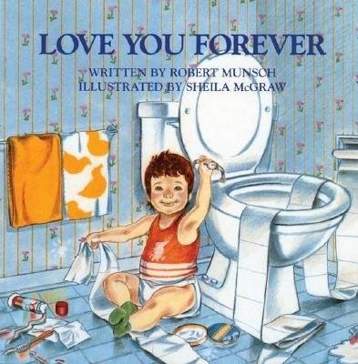  Love You Forever (by Robert Munsch) | A young woman holds her newborn son and looks at him lovingly. Softly she sings to him: "I'll love you forever, I'll like you for always, as long as I'm living my baby you'll be." So begins the story that has touched the hearts of millions worldwide.
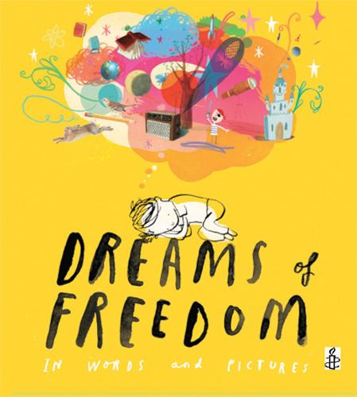  Dreams of Freedom (by Amnesty International) | This inspirational book, following We Are All Born Free, contains 17 quotations about many different aspects of freedom, from the freedom to have an education to that not to be hurt or tortured, the freedom to have a home and the freedom to be yourself. All the chosen quotations are in simple words that can be understood by young children.  Authors of the quotations include: Nelson Mandela, Martin Luther King, Harriet Tubman, Anne Frank, the Dalai Lama, Aung San Suu Kyi and Malala Yousafzai.

