

St. Laurence’s CE Primary School
Maths Handbook

Growing in Faith, Living in Hope, Learning to Love



A message from the Math’s lead…
Welcome to our Maths handbook! As the Maths Lead, I am thrilled to introduce this valuable resource designed to support and enhance our pupils’ journey in mathematics education. The aim of this handbook is to provide information, tools and tips for teaching staff, parents and families as well as visitors around how Maths is carried out at St. Laurence’s. Rooted in continuous professional development (CPD) and innovative pedagogical strategies, our curriculum is designed to meet the evolving needs of both educators and pupils.
Our mission is to foster a deep understanding and love for mathematics among our pupils, ensuring they build strong foundational skills and develop critical thinking abilities that will serve them throughout their educational journey as well as their lives.

Mathematics is more than just numbers and equations; it is a way of thinking, reasoning, and solving problems. It is an essential skill that opens doors to countless opportunities. With this handbook, we aspire to build a strong community of learners where everyone—teachers, parents, and pupils—feels equipped, supported, and motivated to succeed in mathematics.

Miss Hindhaugh
Maths Lead
St. Laurence’s CE Primary School

Contents
- The Curriculum at St. Laurence’s
- What does a Maths lesson look like at St. Laurence’s?
  - Mastering Number
  - White Rose Maths
- Our approaches to assessment
- The culture of Maths across St. Laurence’s
  - Raising the profile of Maths
  - How we support families
  - Home learning
  - Related policies

Section 1: The Curriculum at St. Laurence’s
At St. Laurence’s we aim for every child to be fluent and confident in the fundamentals of Maths by the time they leave St. Laurence’s in Year 6. As a school we will encourage this through varied and frequent practice to develop conceptual understanding and the ability to recall and apply their knowledge rapidly and accurately. Throughout their journey we aim to increase their understanding following a concrete-pictorial-abstract approach in every year group for pupils to develop meaningful and valid problem-solving strategies. This will enable them to follow lines of enquiry, make links and develop justification to be able to reason mathematically to prove their ideas using appropriate mathematical vocabulary.
The aims of our school alongside the aims of National Curriculum for Maths, were the basis for how our curriculum is planned:
When children first begin their learning journey in the Early Years Foundation Stage, it is important they begin to build up their mathematical learning blocks. The Mastering Number programme developed by the National Centre for Excellence in the Teaching of Mathematics (NCETM) aims to secure firm foundations in development of good number sense for all children from Reception through to Year 1 and Year 2. Alongside Mastering Number, White Rose Maths is used from Reception through to Year 6. White Rose Maths aims to provide an ambitious, connected curriculum accessible to all pupils in school as well as providing pedagogic advice for teachers. At St. Laurence’s both curricula are woven throughout, working alongside each other.
As well as the main offer of our Maths curriculum, pupils have access to Maths enhancements. As a school we subscribe to Maths Circle with the online platforms – Numbots and Times Tables Rock Stars (TTRS). Numbots is used from Reception and through KS1 to ensure children develop a core understanding of the three core elements of arithmetic: subitising, number bonds and addition and subtraction. TTRS is also available to every pupil, however promoted within upper KS1 and KS2 to build on their addition and subtraction knowledge. TTRS is a programme used for boosting children’s fluency and recall in multiplication and division.

Yearly Overview
Year Group | What do they get? | When do they get it?
Reception | Mastering Number sessions  White Rose Maths lessons  Numbots  Continuous provision activities – within our indoor and outdoor provision pupils have opportunities to secure and deepen taught knowledge from previous weeks | - Mastering number sessions are carried out 4 times a week; with a fifth session being focused on Shape, Space and Measure from the White Rose curriculum  - Numbots is used for home learning in reception.
Year 1 | White Rose Maths lessons  Mastering Number sessions  Numbots | - 5 x White Rose Maths lessons a week (Autumn Term: 3 evidenced lessons)  - 4 x Mastering Number sessions  - Numbots is used for home learning as well as in the provision and visits from the Mathlete team once a week
Year 2 | White Rose Maths lessons  Mastering Number sessions  Numbots / TTRS | - 5 x White Rose Maths lessons a week  - 4 x Mastering Number sessions  - Numbots is used for home learning as well as in the classroom and visits from the Mathlete team once a week
Year 3  and  Year 4  and  Year 5 | White Rose Maths lessons  Mastering Number sessions  TTRS | - 5 x White Rose Maths lessons a week  - 4 x Mastering Number sessions  - 1 x fluency session  - TTRS is used for home learning as well as in the classroom
Year 6 | White Rose Maths lessons  Fluency session – This session focuses on taught knowledge in order to recap, deepen and secure pupil’s understanding and confidence in areas of the curriculum  TTRS | - 5 x White Rose Maths lessons a week  - 1 x fluency session a week  - TTRS is used for home learning as well as in the classroom

Section 2: What does a Maths lesson look like at St. Laurence’s?
The structure of our Maths lessons has been developed by researching, working with external professionals and other schools. Each section has been carefully chosen to provide the pupils with different skills and learning opportunities.
2.1. Mastering Number
Reception, Year 1 and Year 2 access Mastering Number within their Maths learning.
Reception use White Rose Maths to cover Shape, Space and Measure checkpoints using the Mastering Number Lesson Structure to work alongside the way of learning in Reception. Here is the structure:
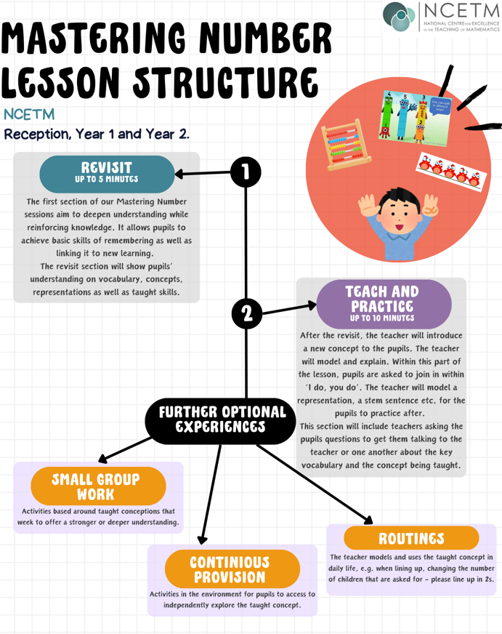

2.2. White Rose Maths
Year 1 up to Year 6 use a different lesson structure within their Maths lessons based around the White Rose Maths scheme.
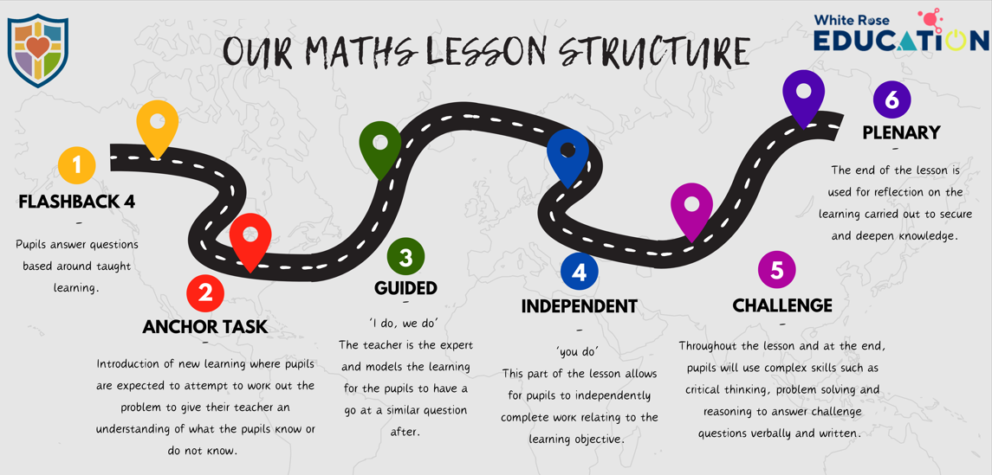
Aspect of lesson | What is it? | If you walked into a classroom, what would you see?
Flashback 4: | This section is a retrieval of the pupil’s knowledge where they answer questions based around taught learning from the same unit, a different unit or a previous year.  This section of the lesson is taken from White Rose Maths following the small steps as they progress. | Flashback 4 is to be used at the start of the maths lesson. Children are to write their answers underneath the LO and then mark their answers in purple pen.
Anchor Task  (AT) | The Anchor Task is new learning where children are expected to attempt to work out the problem to give their teacher understanding of what the pupils know or do not know (AfL).  The AT needs to be a problem open for discussion to allow pupils to explain their reasoning using key vocabulary that they know and understand to see if they can make links from prior knowledge. | The AT is to be carried out daily but evidenced twice a week in pupils’ books.  Discussion should be evident in an AT to allow for pupils to explain their reasoning/working out using key vocabulary.
Guided (G) | ‘I do, we do’:  This section is the teacher being the expert within the input and carrying out explicit modelling relating to the learning objective (in line with our calculation policy, if a calculation unit). The children then use the teacher’s model to work out similar questions. The adults in the room use their assessment for learning to pick up on any misconceptions and pupils who may need more guided questions/scaffolding either through teacher input or resources within the classroom. | This part of the lesson should be rich of vocabulary and talk through discussions, repetition of stem sentences and questioning.  The teacher will model and work through the learning, providing opportunities for talk.
Independent (I) | ‘You do’:  This part of the lesson will include questions based on the lessons objective and teaching they have observed, | Pupils will independently be accessing questions relating to the learning objective. The aim of this section is to see pupils using their mathematical skills whether this is abstractly, pictorially or concretely.  Pupils will have free access to different resources to support them.
Challenge  Teachers to make judgement on how and when pupils complete the challenge | Challenges will be set throughout the lesson where children may need to reason in relation to questioning. However, challenges after the independent will push the pupils to use higher-order thinking, using complex skills such as critical thinking and problem solving. This will come from challenges that involve problem solving or finding different ways of working out calculations and explaining it using mathematical vocabulary. | Challenges are set by the teacher and can be evident in different ways, whether this is recorded in books, on a whiteboard or through discussion.  Once pupils have had a chance to solve the challenge, the teacher will work through it with them to discuss any misconceptions or deepen their understanding.
Plenary | The end of the lesson is used for reflection on the learning carried out to secure and deepen knowledge around the lesson’s learning. | Whole class discussion based on key knowledge taught which can be carried out through questioning, stem sentences or explanations.
Scaffolds  and adaptive teaching | At St. Laurence’s we acknowledge that every child is different and will have different ways of learning which has resulted in our view on the importance on concrete-pictorial-abstract.  These different stages will support each child and give them the chance to access the same learning as their peers.  We also appreciate some pupils will need different adaptations to enable this. As a school we provide many scaffolds to help our pupils. | - teacher/teaching assistant support  - pre-teaching  - small group guided work  - access to maths resources (CPA)  - daily safety nets  - half termly/termly interventions  - work adapted based on ability and needs

Section 3: Our approaches to assessment
Assessments are an integral part of today’s teaching, learning and data decisions. We carry out both assessment for learning (formative) and assessment of learning (summative).
Assessment for Learning
When? | Throughout learning, daily.
Why? | Helps to gather immediate information around students’ knowledge, understanding and skills to inform teaching. This allows for teachers to provide feedback about their learning and how to improve.
How? | - Questioning during learning  - Quick write ‘show me’  - Partner talk  - Peer assessment  - Self-assessment  - Discussions  Plus many more.

Assessment of Learning
Who? | What do they do? | When do they do it?
Reception | Assessed against key substantive mathematical knowledge | Throughout the year at data check points
Year 1, Year 3, Year 4 and Year 5 | End of unit assessments  End of term assessments  Multiplication Tables Check | Carried out at the end of every unit (White Rose Maths)  Carried out before data check points in the Autumn, Spring and Summer (White Rose Maths)  June
Year 2 and Year 6  (End of Key Stage) | End of unit assessments  End of term assessments  SATs papers | Carried out at the end of every unit (White Rose Maths)  Carried out before data check points in Autumn and spring (past SATs papers)  Carried out in the Summer term

Section 4: The culture of Maths across St. Laurence’s
4.1. Raising the profile of Maths
How is Maths promoted at St. Laurence’s?
- Mathletes
As well as teacher subject leaders, we have pupil leadership teams. For Maths, these are known as ‘Mathletes’. This team consists of pupils from KS2 who support the Maths lead. Their duties include:
- Supporting younger pupils in Reception and KS1 to access Numbots and TTRS
- Helping with fundraising events
- Learning walks, looking at displays etc.
- Hosting assemblies

- Weekly Rockers
Pupils from every class will have a chance to win a ‘Weekly Rocker’ award each week in celebration assembly. The certificates award pupils on their achievements from TTRS and Numbots. Each week will have a different focus which can range from number of correct answers to average time spent online over the past 7 days. Pupils love to find out who is their weekly rocker!
- Fundraisers
We use Maths to promote and fundraise for charities. For example, we take part in Number Day which supports and raises money for the NSPCC! We raise the money by paying to dress up as numbers, from a cake sale etc.
4.2. How we support families
In order for families to support their children in their learning, they need to understand how Maths is taught and implemented within school. All information regarding Maths is on our school website:
https://www.stlaurences.covmat.org/maths-2/
There will be opportunities over the academic year for parents and carers to come into school to talk about, observe or take part in activities based on how Maths at St. Laurence’s!
4.3. Home Learning
All pupils throughout the school have access to TTRS and Numbots outside of school as well as in school. They can practice their mathematical skills on there as much as they like and take part in nationwide competitions e.g. England Rocks! Teachers may also set home learning based around their current Maths learning.
As well as this, teachers will provide a biweekly fluency homework activity to support with their calculation processes (Year 1-5).

4.4. Policies
At St. Laurence’s we have different policies to ensure pupils have consistency within their Maths learning:
- Maths environment
All working walls must show the unit, the vocabulary (using our vocabulary document for this), examples as well as stem sentences. There also, needs to be a daily maths problem around for the children.
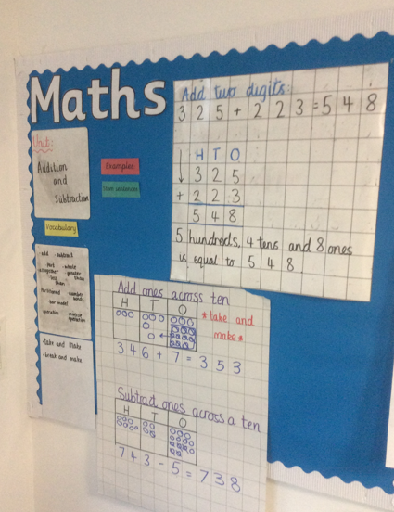
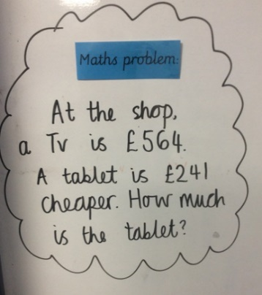

In order for the children to become more independent, having a maths area will help. This area needs to be accessible for the children with concrete and pictorial resources for them to use to support them if needed.

- Marking

Green – dot for improvements, tick if correct
Safety Net Time is completed with the pupils by an adult to ensure the misconception is rectified before moving onto the next step of learning – adult to initial and date.

If a child has had verbal feedback - VF is written in a circle.
Feedback is used in a variety of ways to develop and extend knowledge including; number formation practice, corrections and problem solving and reasoning to apply the knowledge in a different way/situation.

Sp to be written if child has spelt key vocabulary wrong, child to rewrite word 3 times.

- Presentation

- Each page in the Maths books has a margin 2 squares wide.
- The short date is written on the left next to the margin and is underlined e.g. 23.11.22.
- The title of the small step is written under the date and is underlined.
- Children use 1 digit per square.
- Rulers are used to draw all straight lines.
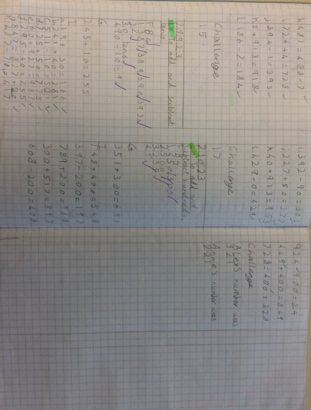
- Children should be using their whole maths page before moving on to the next page; splitting into two columns (see below for example) – only if they are correctly setting out work using all steps above.

- Calculation Policy
Calculation policies are incredibly important documents, particularly for the teaching staff, as they should provide the guidance and expectations for the teaching of addition, subtraction, multiplication and division for each year group. A calculation policy allows for consistency and progression throughout the school and reflects a whole school agreement.
At St. Laurence’s our calculation policy shows the processes of concrete, pictorial and abstract in each year; showing the progression from year to year. It provides both teachers and pupils with appropriate strategies for them to use when carrying out calculations.
Please see our calculation policy for more information.

- Vocabulary expectations
At St. Laurence’s we have a vocabulary progression document to follow from Early Years up to Year 6 for teachers and support staff to follow in each unit of work.
Our intent is to embed the understanding of vocabulary. We are a multi-diverse school with pupils with different needs. Therefore, them knowing the key vocabulary is important, but, it is essential they have the understanding to go with it.
Children need to be able to talk and reason using the key vocabulary they have been taught using this document:
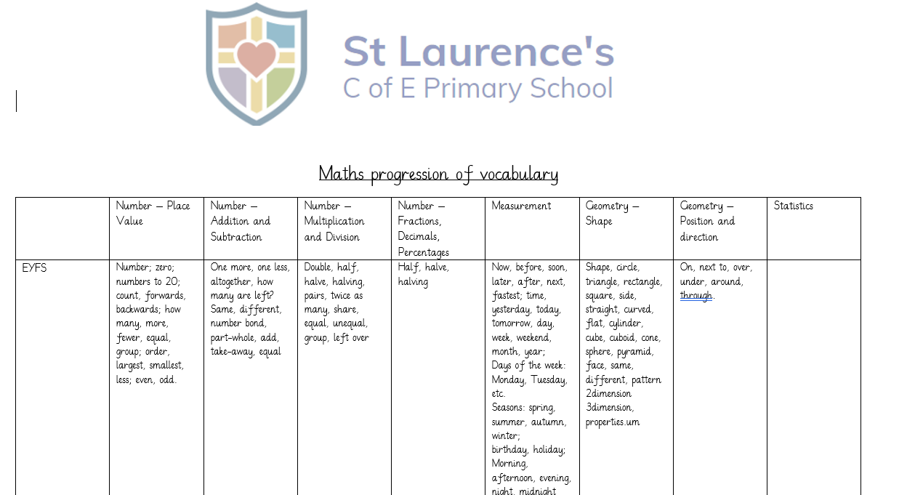

In order to help pupils understand vocabulary, it needs to be taught. This can be done at a beginning of a unit, or as and when it comes up within them lessons, making it explicit.
To assess pupil’s understanding teachers will use questioning, trying to deepen their explanations when they give them whether this is written or verbal. This will be using questions such as:
“Why/why not?” “How do you know?” “What does that mean?”
Questions within their independent practice should also include the use of vocabulary through problem solving and reasoning questions.
Please see our Vocabulary Progression document for more information.

