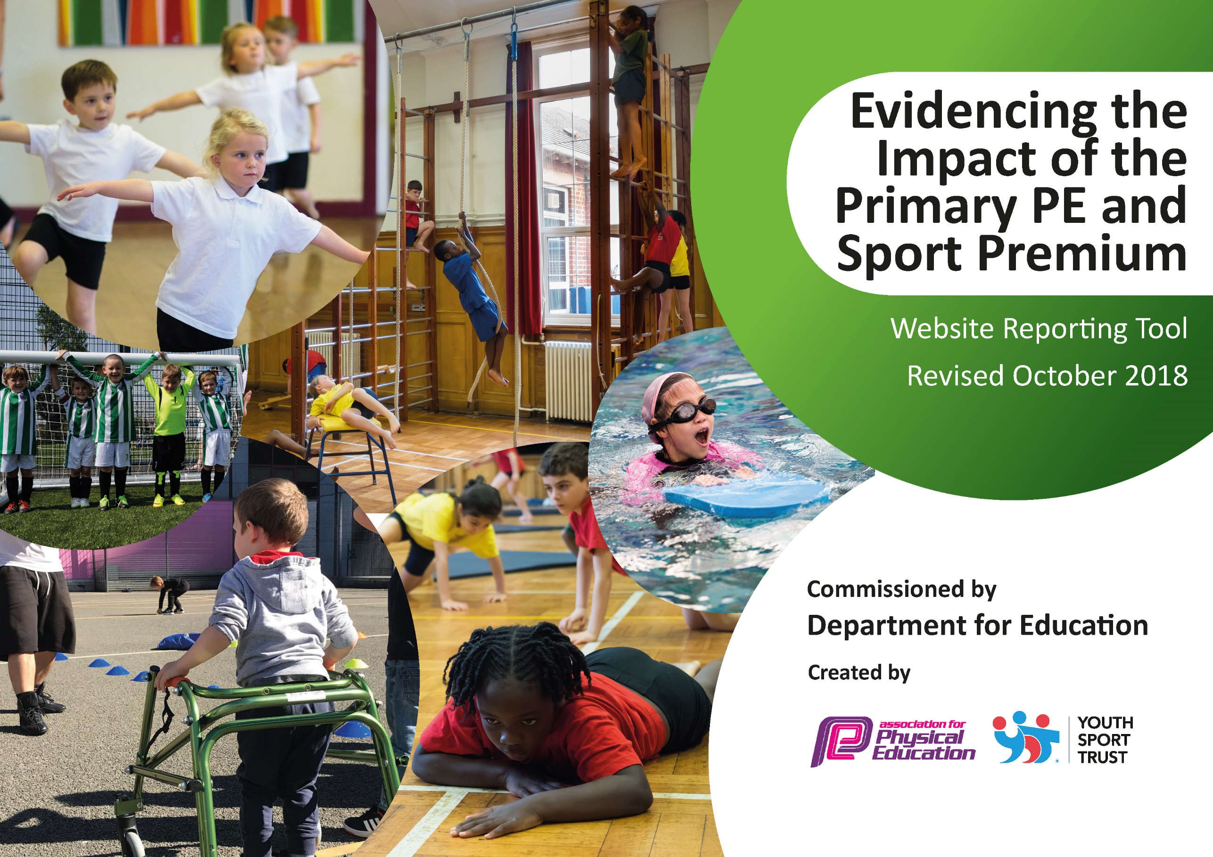
js
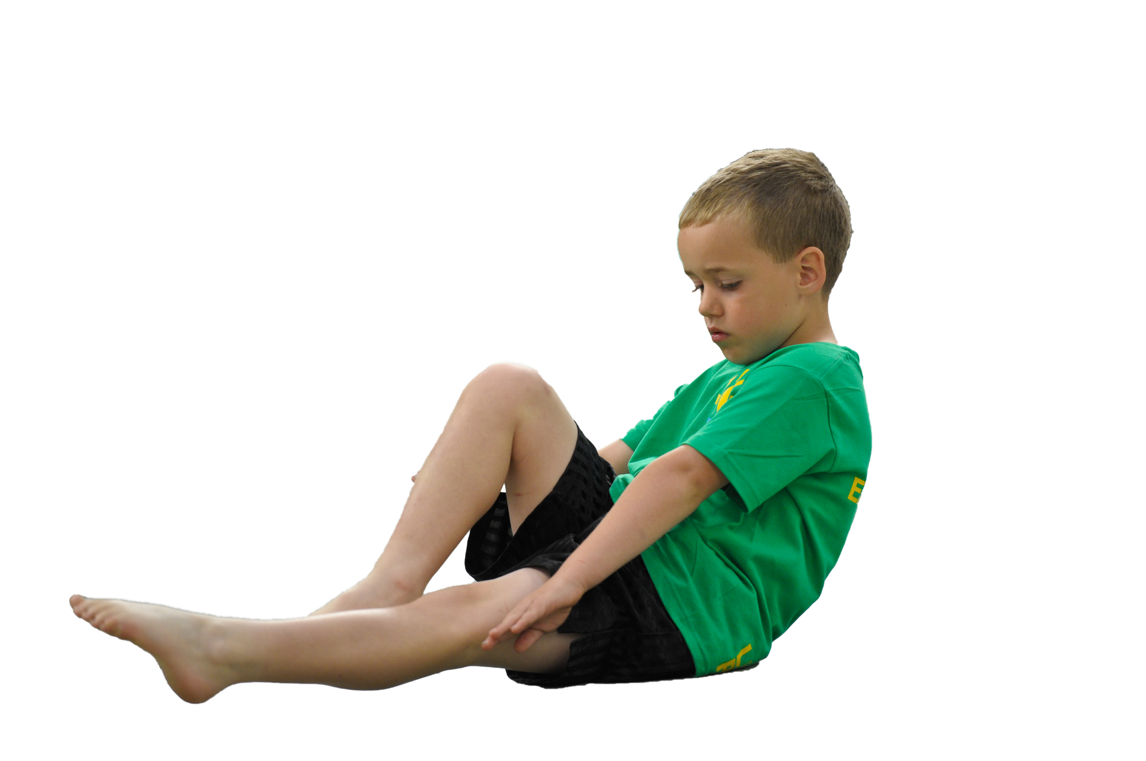
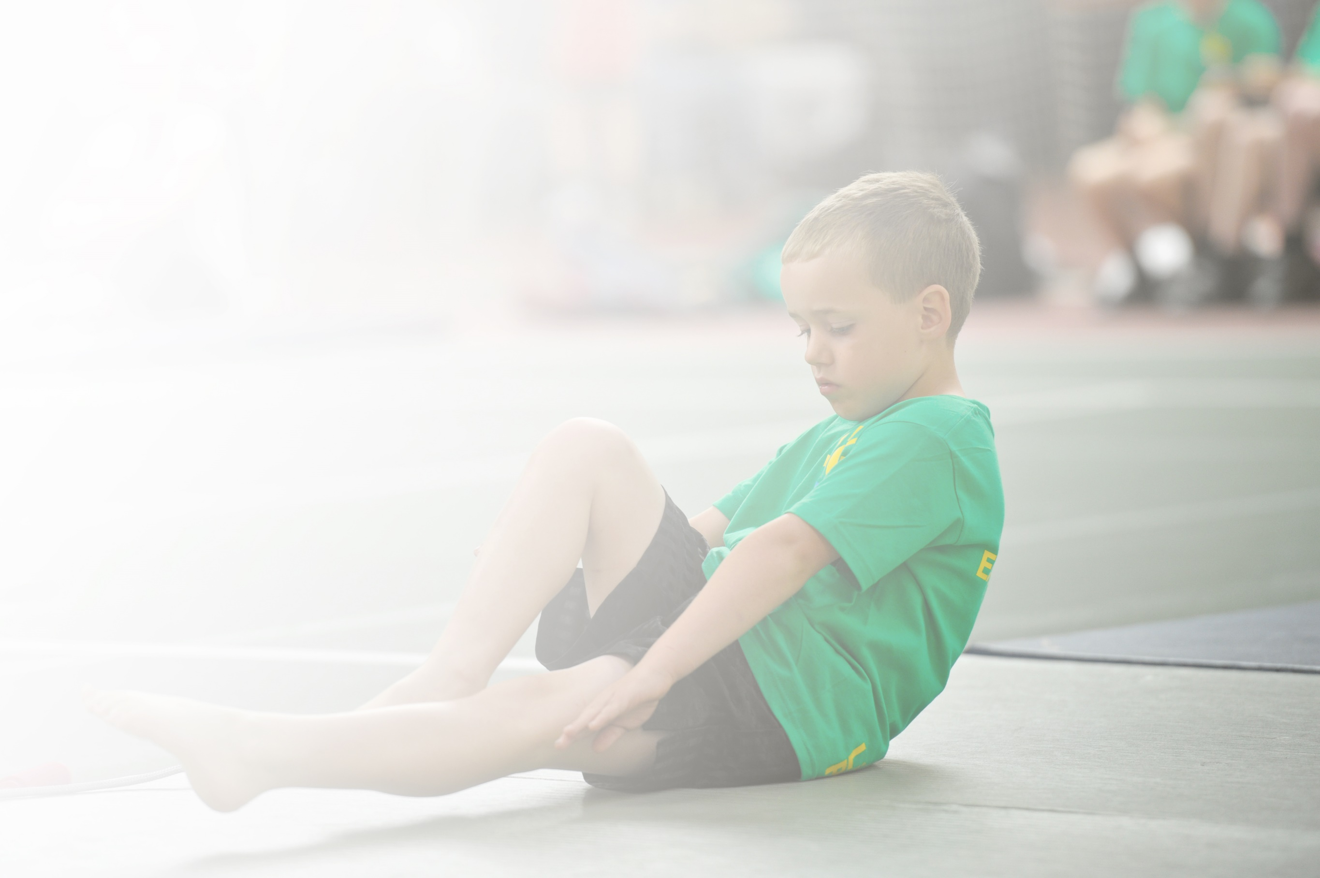
Schools must use the funding to make additional and sustainable improvements to the quality of Physical Education, Sport and Physical Activity (PESPA) they offer. This means that you should use the Primary PE and Sport Premium to:

- Develop or add to the PESPA activities that your school already offer
- Build capacity and capability within the school to ensure that improvements made now will benefit pupils joining the school in future years

Please visit gov.uk for the revised DfE guidance including the 5 key indicators across which schools should demonstrate an improvement. This document will help you to review your provision and to report
your spend. DfE encourages schools to use this template as an effective way of meeting the reporting requirements of the Primary PE and Sport Premium.

We recommend you start by reflecting on the impact of current provision and reviewing the previous
spend. Under the Ofsted Schools Inspection Framework, inspectors will assess how effectively leaders use the Primary PE and Sport Premium and measure its impact on outcomes for pupils, and how effectively governors hold them to account for this.

Schools are required to publish details of how they spend this funding as well as on the impact it has on pupils’ PE and sport participation and attainment by the end of the summer term or by 31 July 2019 at the
latest.
We recommend regularly updating the table and publishing it
on your website throughout the year, as evidence of your
ongoing review into how you are using the money to
secure maximum, sustainable impact. To see an
example of how to complete the table please
click HERE.

Support for review and reflection - considering the 5 key indicators from DfE, what development needs are a priority for your setting and your students now and why? Use the space below to reflect on previous spend, identify current need and priorities for the future.

Key achievements to date: | Areas for further improvement and baseline evidence of need:
- Embedded Gifted and Talented After school tennis club in partnership with CNW Tennis as part school sports provision  - Over 70% children attending afterschool sports clubs in Autumn & Spring term  - A group of 16 Coventry Young Ambassador trained as volunteers who supported city-wide sporting and cultural events linked to Coventry being European Capital of Sport (2019) and Capital of Culture (2021)  - 73% of pupils engage in at least 1 after-school club across the year  - 33 % of KS2 Girls engage in at least 1 after-school club across the year  - 65% of KS2 pupils engaged in lunchtime sports activities across the year  - 24% of KS2 girls engaged in lunchtime sports activities across the year  - 18% of all pupils engage in School Sport competitions  - 20% of KS2 pupils engage in School Games events | - Implement training from PE leaders’ course to upskill new staff to develop their knowledge, experience and confidence in delivering PE and Sports lessons  - Survey staff to find out current levels of confidence, skill and knowledge in delivering PE  - Implement action plan on the results of staff survey  - Continue to survey School Council and School Games Council to review pupil needs, likes and dislikes  - Further training to play leaders (school games council) to lead and develop games and activities at lunchtimes  - Assess the impact of Forest Schools to see where it can be embedded in the school curriculum  - Provide further opportunities for Coventry Young Ambassadors to tie in with Coventry Year of Sport and City of Culture

Meeting national curriculum requirements for swimming and water safety | Please complete all of the below:
What percentage of your current Year 6 cohort swim competently, confidently and proficiently over a distance of at least 25 metres?  N.B. Even though your children may swim in another year please report on their attainment on leaving primary school. | 34/59 = 63%
What percentage of your current Year 6 cohort use a range of strokes effectively [for example, front crawl, backstroke and breaststroke]? | 21/59 = 36%
What percentage of your current Year 6 cohort perform safe self-rescue in different water-based situations? | 57/59 = 96%
Schools can choose to use the Primary PE and Sport Premium to provide additional provision for swimming but this must be for activity over and above the national curriculum requirements. Have you used it in this way? | We had arranged additional swimming lessons for the summer term but could not attend due to Covid-19.

Action Plan and Budget Tracking
Capture your intended annual spend against the 5 key indicators. Clarify the success criteria and evidence of impact that you intend to measure to evaluate for students today and for the future.

Academic Year: 2019/20 | Total fund allocated: £19,500 | Date Updated: 21st July 2020
Key indicator 1: The engagement of all pupils in regular physical activity – Chief Medical Officer guidelines recommend that primary school children undertake at least 30 minutes of physical activity a day in school |  |  |  | Percentage of total allocation:
 |  |  |  | %
School focus with clarity on intended impact on pupils: | Actions to achieve: | Funding allocated: | Evidence and impact: | Sustainability and suggested next steps:
PE coordinator attended training on Active Maths and English.  Deliver Premier League Primary stars CPD to Year 3 teachers in partnership with Sky Blues in the community  Provide a structured timetable of lunchtime activities to enable all pupils to engage in at least 1 extra-curricular activity. | Active Maths & English INSET delivered to all teaching staff  Purchase Active teaching resources.  Training booked for summer term  Consult school council on activities. Plan timetable and promote in assembly. Timetable place on sports board for children to view | TBC  £500  LW costs for 0.5hrsx5/39wks | INSET yet to be delivered so no impact attained to date  CPD not delivered due to lockdown  65% of KS2 pupils engaged in lunchtime sports activities across the year  24% of KS2 girls engaged in lunchtime sports activities across the year | INSET delivered to staff to embed Active Maths and English into the school day  Re-book training when safe  Work towards engaging 75% of KS2 children and 40% of girls in lunchtime activities. Collate data for KS1.
Key indicator 2: The profile of PESSPA being raised across the school as a tool for whole school improvement |  |  |  | Percentage of total allocation:
 |  |  |  | %
School focus with clarity on intended impact on pupils: | Actions to achieve: | Funding allocated: | Evidence and impact: | Sustainability and suggested next steps:
Continue to highlight and promote PESSPA through celebration assemblies, newsletters, twitter, match reports and sport notice board  Retained school Games bronze award  Continue to participate in SG events to raise profile of sports and SG in school. Sporting success and activity also promoted in school assemblies  Subscription to Coventry Primary Schools Sports Association  Host SG Rounders’ competition in summer term  Deliver +Sport Health project to year 5 in partnership with Sky Blues in the Community  New sports and PE equipment purchased to help deliver high quality PE lessons and after-school clubs and support the improvement in performance in school competitions  Identify gifted and talented children in years 3-6 and deliver 30 min sessions targeting competitions  Purchase trophy cabinet to highlight the schools recent sporting successes | Children to write reports. Images uploaded to social media  Develop scrap book to highlight PESSPA in office area for visitors to view.  Add information to SG website  Children given certificates and awards in celebration assembly  Registered to CPSSA  2 Rounders pitches to be marked on to school field. Replace rounder’s equipment  Project booked in to be delivered during Summer Term 2 every Tuesday afternoon  Appropriate equipment (including rowing machine, and Archery, Boccia & Boxing sets) purchased to deliver PE curriculum and afterschool clubs and help focus on SG events  Sports Coach working with groups to improve performances in sports and activities linked to SG competitions  Cabinet purchased and placed in the office area for visitors to view | N/A  £280  SG contribution  £50  TBC  Free  £3500  N/A  £TBC | Post to social media. School Newsletter and Sports notice board.  School given same award (Bronze) as last year due to Covid-19  144 children attended school sports competitions during Autumn & Spring terms  45 children participated in CPSSA sporting competitions. Afterschool netball developed with 20 regular participants per week  Competitions cancelled due to lockdown  Project cancelled due to lockdown. (60 children would have completed health project).  Boxing & Fitness lessons added to PE curriculum for Year 5&6 in Spring Term 1  Archery & Boccia lessons added to PE curriculum in Spring Term 1  144 children attended extra lessons focusing on improving performance in competitions  3 new shields or trophies added to trophy cabinet | Scrap book to be added to school office  Work towards Silver Award from SG  Continue to participate in SG competitions and offer to host further events including Quad Kids  Continue to participate in CPSSA events. Year 6 teachers to deliver Afterschool Netball club for B-Team.  Offer to host events next year  Re-book project for next year  Introduce Boxing Fitness sessions to breakfast club and Least Active children. Introduce inclusive afterschool club  Develop Sportshall Athletics and gymnastics afterschool clubs  Add certificates received from School Games during contribution towards Autumn and Spring events as well as virtual competitions during summer.

Key indicator 3: Increased confidence, knowledge and skills of all staff in teaching PE and sport |  |  |  | Percentage of total allocation:
 |  |  |  | %
School focus with clarity on intended  impact on pupils: | Actions to achieve: | Funding  allocated: | Evidence and impact: | Sustainability and suggested  next steps:
Attend Level 5 course in Primary School PE specialism through the PE Hub  Conduct staff audit on opinions, confidence and skill when delivering PE | Book course and attend 1 training day per half-term  Send out staff questionnaire, collate feedback and plan actions | £500  Free | Sports coach currently attending course  % have positive attitude towards PE  % confident to deliver own PE lesson | Sports coach to implement strategies from the course into school PE journey  Plan actions moving forward to increase knowledge and skills of teachers. INSET day on PE delivery
Key indicator 4: Broader experience of a range of sports and activities offered to all pupils |  |  |  | Percentage of total allocation:
 |  |  |  | %
School focus with clarity on intended  impact on pupils: | Actions to achieve: | Funding  allocated: | Evidence and impact: | Sustainability and suggested  next steps:
Attended Orienteering CPD course and added orienteering to year 5&6 PE curriculum in Summer Term  Boxing & Fitness lessons added to PE curriculum for Year 5&6 in Spring Term 1  Archery & Boccia lessons added to PE curriculum in Spring Term 1  12-week focused reading project called Premier League Reading Stars delivered to a group of year 4 pupils through Sky Blues  Provide a varied after-school club to provide the opportunity for as many children as possible to participate in active sports  Build on Girls after-school provision to offer Netball and Football after-school clubs to improve numbers of girls regular participating in extra-curricular sport | Purchase orienteering resources and add Orienteering to PE curriculum  Purchase resources and plan unit of work  Purchase resources and plan unit of work  Sky Blues in the Community delivering a 12-week reading programme to improve year 4 engagement in reading using football as a tool  Work with school council to give children a voice to ensure we offer activities children enjoy  Offer Girls Football and Netball and promote clubs in assembly | Claimed above  Claimed above  Claimed above  £300  LW After school costs 1hrx5/39wks  LW costs from above | Orienteering lessons delivered to 70 children from Year 6 and Key worker bubbles following lockdown  120 children from Year 5 & 6 received health and fitness lessons using boxing-based activities  120 children from Year 3 & 4 received Archery & Boccia lesson focusing on inclusive based activities  Project not delivered due to lockdown  73% of pupils engage in at least 1 extra-curricular club across the year  33 % of KS2 Girls engage in at least 1 extra-curricular club across the year | Keep in PE curriculum. Get school mapped. Purchase further resources.  Keep boxing activities in PE curriculum, Purchase further resources. Attend further training  Keep Archery and Boccia in PE curriculum and attend inclusive training  Re-book for next year  Re-engage school council to ensure we meet the needs of pupils. Get Teachers to help run clubs  Aim for target of 50% of girls engaged in after school clubs
Key indicator 5: Increased participation in competitive sport |  |  |  | Percentage of total allocation:
 |  |  |  | %
School focus with clarity on intended  impact on pupils: | Actions to achieve: | Funding  allocated: | Evidence and impact: | Sustainability and suggested  next steps:
Attended Orienteering CPD course offering alternative sporting competition for those who may be less active or not interested in traditional sports activities  Continue to be engaged in SG and CPSSA competitions | Register interest for SG Orienteering competition in summer term  Compete in SG competitions throughout they year. Compete in CPSSA football and netball competitions | Free  Costed above | Competition cancelled due to lockdown  Boys won SG rowing competition and qualified for the county final.  Girls finished 5th in SG rowing competition.  Netball team were 1st in their pool and in the semi-final of the netball plate before lockdown  21% of all pupils engage in School Sport competitions during Autumn and Spring Term  20% of KS2 pupils engage in School Games events during Autumn and Spring Term  25% of pupils took part in virtual competition | Get school mapped  Host more SG competitions including (Rounders and Quad Kids)  Numbers are low due to Covid-19. Aim to improve towards 50% of KS2 pupils engaged in sporting events.

